**LAB – 12**

18MIS7250

Amit Kumar Sahu

**HDLC, PPP, PAP & CHAP**

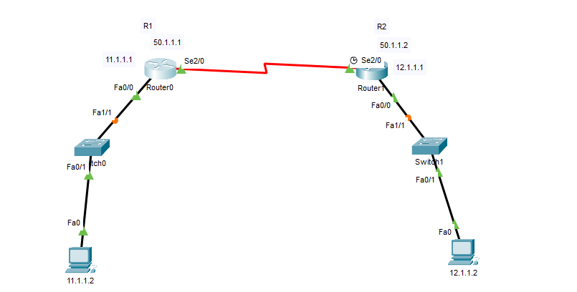

High-level Data Link Control (**HDLC**) is a group of communication protocols of the data link layer for transmitting data between network points or nodes. Since it is a data link protocol, data is organized into frames. A frame is transmitted via the network to the destination that verifies its successful arrival.

**Configuring router**

Router(config)#interface FastEthernet0/0

Router(config-if)#ip add 12.1.1.1 255.0.0.0

Router(config-if)#no shut

Router(config-if)#

Router(config)#int

% Incomplete command.

Router(config)#interface FastEthernet1/0

Router(config-if)#

Router(config-if)#exit

Router(config)#interface FastEthernet0/0

Router(config-if)#no shutdown

Router(config-if)#

%LINK-5-CHANGED: Interface FastEthernet0/0, changed state to up

%LINEPROTO-5-UPDOWN: Line protocol on Interface FastEthernet0/0, changed state to up

Router(config-if)#int s2/0

Router(config-if)#ip add 50.1.1.2 255.0.0.0

Router(config-if)#no shut

**Enabling PPP on both the routers**

Router(config)#int s2/0

Router(config-if)#encapsulation PPP

Router(config-if)#

%LINEPROTO-5-UPDOWN: Line protocol on Interface Serial2/0, changed state to down

**PAP - Password Authentication Protocol**

Router>en

Router#conf t

Enter configuration commands, one per line. End with CNTL/Z.

Router(config)#hostname R1

R1(config)#enable password cosco

R1(config)#username R2 password cosco

R1(config)#int s2/0

R1(config-if)#encapsulation PPP

R1(config-if)#ppp authentication ?

chap Challenge Handshake Authentication Protocol <CHAP>

pap Password Authentication Protocol <PAP>

R1(config-if)#

%LINEPROTO-5-UPDOWN: Line protocol on Interface Serial2/0, changed state to down

R1(config-if)#ppp pap sent-username R1 password cosco

R1(config-if)#

%LINEPROTO-5-UPDOWN: Line protocol on Interface Serial2/0, changed state to up

Router 2nd configuration

Router#conf t

Enter configuration commands, one per line. End with CNTL/Z.

Router(config)#

Router(config)#hostname R2

R2(config)#enable password cosco

R2(config)#

%LINEPROTO-5-UPDOWN: Line protocol on Interface Serial2/0, changed state to down

R2(config)#int s2/0

R2(config-if)#encapsulation ppp

R2(config-if)#ppp authentication pap

R2(config-if)#^Z

R2#

%SYS-5-CONFIG_I: Configured from console by console

R2#conf t

Enter configuration commands, one per line. End with CNTL/Z.

R2(config)#username R1 password cosco

R2(config)#

R2(config)#int s2/0

R2(config-if)#ppp pap sent-username R2 password cisco

R2(config-if)#

**Restarting Both The Routers And Configuring CHAP**

R1(config-if)#int s2/0

R1(config-if)#encapsulation ppp

R1(config-if)#ppp authentication chap

R1(config-if)#

R1(config-if)#exit

R1(config)#username R2 password cisco